Electric Bicycle Instruction Manual

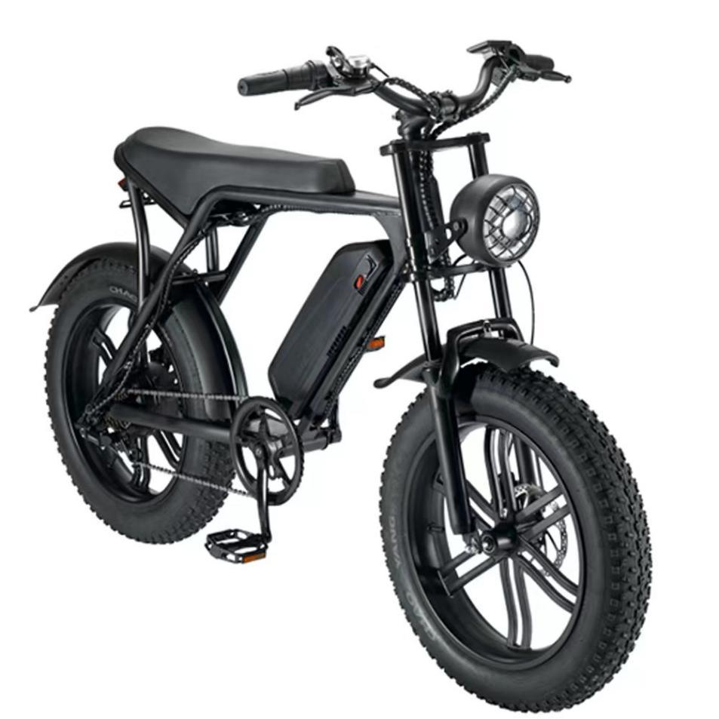

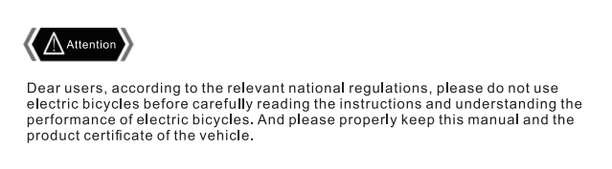

Table of Contents
Important Safety Information 1
V8 Parts Identification 2
Configuration Table 3
Pre-Ride Safety Checklist 4
Driving Safety -- -------7
Assembly Instructions 9
Gears Operation 16
Charging Procedure 17
Battery Charging Information -----------------------------------------------------------------------------------------------------------------------19
Maintenance -------------------------------------------------------------------------------------------------------------------------------------------20
Troubleshooting 21

Safety Notes 23

1

IMPORTANT SAFETY INFORMATION
WARNING:
Electric bikes can be dangerous to use. The user or consumer assumes all risk of personal injuries, damage, or failure of the bicycle or system and all other losses or damages to themselves and others and to any property arising as a result of using the bicycle.
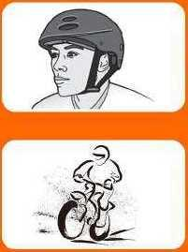
It is important for you to understand your new bicycle. By reading this manual before you go out on your first ride, you’ll know how to get better performance, comfort, and enjoyment from your new bicycle. It is also important that your first ride on your new bicycle is taken in a controlled environment, away from cars, obstacles, and other cyclists.
1 .Always Wear A Helmet
Helmets significantly reduce the number and safety of head injuries.Always wear a helmet that complies with your state laws when riding the E-bike .Check with your local police department for requirements in your community.Make yourself more visible by wearing bright reflective clothing.Keep your reflectors clean and eye protection.Also check your state laws concerning other protective gear that may be required when riding the E-bike.
2.Know Your E-bike
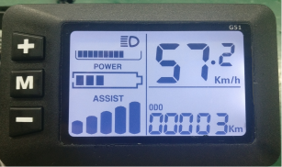
Your new E-bike incorporates many features and functions that have never been built into a bicycle before.Read this manual thoroughly to understand how those features enhance your riding pleasure and safety.
3.Ride Within Your Limits
Take it slow until you are familiar with the riding conditions that you encounter.Be especially careful in wet conditions as traction can be greatly reduced and brakes becoming less effective.Never ride faster than conditions warrant or beyond your riding abilities.Remember that alcohol,drugs, fatigue and inattention can significantly reduce your ability to make good judgement and safety.
4.Keep Your E-bike In Safe Condition
For your safety and enjoyment,and to insure a long life for your E-bike. Inspect and maintain your E-bike regularly.Follow the inspection and maintenance guidelines beginning on page 3.Check critical safety equipment before each and every ride.
1
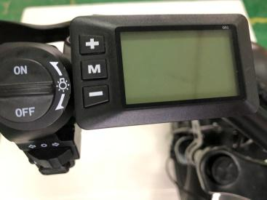
V8 PARTS IDENTIFICATION
Display
Boot keys
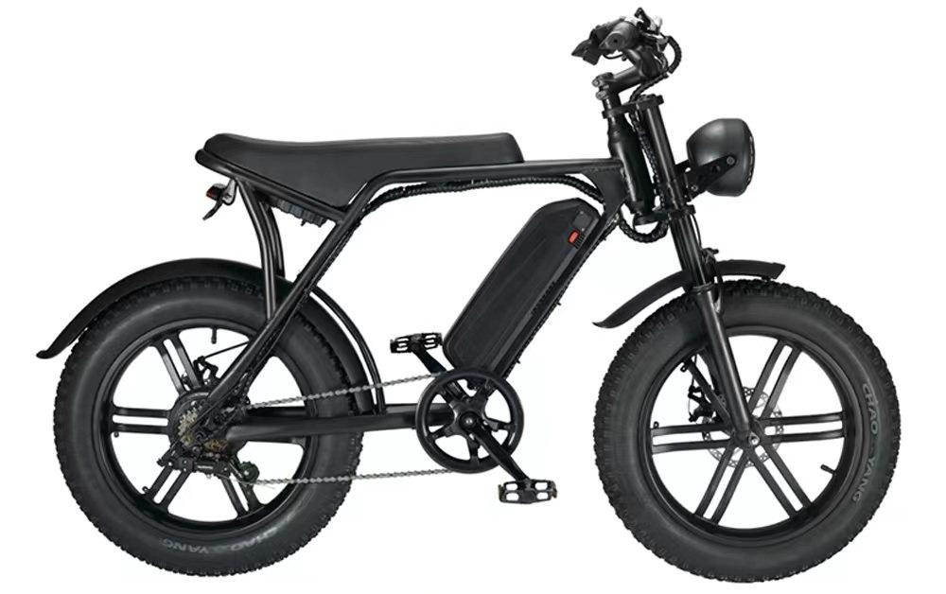
Seat

Battery
LED Headlight

Tire IRE
Crank
IRE
Chain IRE
Pedals IRE
Handlebar
Bike Frame
Front Fork
Front fender
Disc brake rotor
Tire IRE
Rear Light
Controller
Gear buttons
The headlight switch
Rear derailleur
Bike motor
Rear fender
2
Configuration Table
3
Item Name | Product specification
The vehicle size | 165*70*110(CM)
Packing Size | 142.5*27*86.5(CM)
Color | Black, white (customized)
The frame material | Chrome molybdenum steel
Net Weight | 35kg
Gross Weight | 43kg
Max. Support Weight | 150kg
Function 1/2/3 | Power cycling/Before the suspension/SHIMANO shifts gears
The highest speed | 50KM/h(5 gears adjustable)
Inner Tube Tire Press | 20PSI / 140KPA
Bike Computer | V8-G51
Charger | AC-DC 54.6V 2A 100-240V AC DC5.5X2.1
Battery | 48V10AH/12.5/AH/15AH
Brake system | Front and rear hydraulic disc brake
Tire | 20×4.0
Pedal | Aluminum alloy pedal

Pre-Riding Safety Checklist
Notice:Before every riding,and after every 25-45 miles,we advise following the pre-riding safety checklist in the table below.

Safety Check | Basic Steps
1. Brakes | ♦ Ensure front and rear brakes work properly  ♦ Check brake pads for wear and ensure they are not over-worn  ♦ Ensure brake pads are correctly positioned in relation to the rims  ♦ Ensure brake control cables are lubricated,correctly adjusted,and display no obvious wear.Ensure brake control severs are lubricated and tightly secured to the handlebars  ♦ Test brake levers are firm and that brake,motor cutoff functions,and brake light are functioning properly
2. Wheels and Tires | ♦ Ensure tires are inflated to within the recommended limits displayed on the tire sidewalls and holding air  ♦ Ensure tires have good tread,have no bulges or excessive wear,and are free from any other damage.  ♦ Ensure rims run true and have no obvious wobbles, dents,or kinks.  ♦ Ensure all wheel spokes are tight and not broken  ♦ Check axle nuts and front wheel quick release skewer is correctly tension, fully closed,and secure position.
3. Steering | ♦ Ensure handlebar and stem are correctly adjusted and tightened and allow proper steering  ♦ Ensure the handlebar is set correctly in relation to the forks and the direction of travel
4. Chain | ♦ Ensure the chain is oiled,clean,and runs smoothly  ♦ Extra care is required in wet.salty/otherwise corrosive,or dusty conditions
5.Bearings | ♦ Ensure all bearings are lubricated,run freely,and display no excess movement grinding,or rattling ♦ Check headset,wheel bearings,pedal bearings,and bottom bracket bearings  4
6.Cranks and Pedals | ♦ Ensure pedals are securely tightened to the cranks  ♦ Ensure the cranks are securely tightened and are not bent
7. Derailleurs | ♦ Check that the derailleur is adjusted and functioning properly  ♦ Ensure shifter and brake levers are attached to the handlebar securely  ♦ Ensure all brake and shift cables are properly lubricated
8. Frame,Fork,and Seat | ♦ Check that the frame and fork are not bent or broken  ♦ If either frame or fork are bent or broken,they should be replaced  ♦ Check that the seat is adjusted,properly and seat post quick release lever is securely tightened
9. Motor Drive Assembly and Throttle | ♦ Ensure hub motor is spinning smoothly and motor bearings are in good working order  ♦ Ensure all power cables running to hub motor are secured and undamaged  ♦ Make sure the hub motor axle bolts are secured and all torque arms and torque washers are in place
10. Battery | ♦ Ensure battery is charged before use  ♦ Ensure there is no damage to battery  ♦ Lock battery to frame and check to see that it is secured  ♦ Charge and store bike and battery in a dry location,between 50*F-77*F  ♦ Let bike dry completely for using again
11.Electrical Cables | ♦ Look over connectors to make sure they are fully seated,free from debris or moisture  ♦ Check cables and cable housing for obvious signs of damage  ♦ Ensure headlight,taillight,and brake light are functioning adjusted properly,and unobstructed  5
12. Accessories | ♦ Ensure all reflectors are properly fitted and not obscured  ♦ Ensure all other fittings on bike are properly secured and functioning  ♦ Inspect helmet and other safety gear for signs of damage  ♦ Ensure rider is wearing helmet and other required riding safety gear  ♦ Ensure mounting hardware is properly secured if fitted with rear rack  ♦ Ensure taillight and taillight power wire are properly secured if fitted with rear rack  ♦ Ensure fender mounting hardware is properly secured if fitted with fenders  ♦ Ensure there are no cracks or holes in fenders if fitted with fenders

Your cables,spokes,and chain will stretch after an initial break-in period of 50-100 mile (80-160km),and bolted connections can loosen.Always have a certified,reputable be mechanic perform on your E-bike after your initial break-in period of 50-100 mile (80-160km) (depending on riding conditions such as total weight,riding characteristics,and terrain).Regular inspections and tune-ups are particularly important for ensuring that your bike remains safe and fun to ride.
6
9
Drive Safety
Please strictly abide by the traffic rules and safe driving speed control within safe speed,(default of safe speed is 30km/h)
Before you dive,please be familiar with the contents of this manual.Then find an empty,flat training,have complete control of the vehicle diving essentials and familiar with its structure, it is the foundation of safe driving.
DANGEROUS: Read the instructions carefully and understand the performance of the electric bicycle before,do not use electric bike,don’t lend it to people won't run the Electric bike riding! Please strictly enforce the traffic rules,don*t drink driving,driving, one hand after separation is very dangerous !
Rain and snow weather driving: want to double pay attention to safety,rain and snow day by the damp ground be dangerous ! Therefore,we should avoid speed,to be especially careful. Especially should remember: brake in advance to prevent snow day! Not afraid of rain,snow on the local weather,but can't wade,when water flooded to the rear wheel motor wheel hub, may cause the vehicle internal wiring short circuit, and damage to the electric appliances, please attention!
Check before riding:
- Please you in the vehicle with double supports,the rear wheel off the ground,under the condition of the power switch is normal use.
- Put through power supply, check the instrument on the indicator light is normal;Check whether the power of electric.
- Check the condition of electric bike horn are in good condition;Lighting switch operation,check the head lights, tail lights lighting is normal.
- The saddle,the saddle tube is adjusted.
- Check before and after the brake lever,brakes should be bug to reset the brake is reliable,flexible,rain and snow weather should increase the braking distance.
- Check the tire pressure is normal? Presence of cracks and abnormal wear and nails,stone,glass and other sharp objects embedded.
Note:Tire pressure disturbance,crack damage and abnormal tire wear is the cause of steering is ineffective.the tire burst
- Check whether the front and rear screw lock and chain conditions are in good condition.
- Check the shaft fastening condition,ensure the front and rear axles and handlebar clamp reliable.
Drive properly:
- Please stand before you start the bike to the left of the main bracket stand, view the vehicle without exception.
2.0pen ON/OFF button.the power display lights,said the power supply has been switched ON.
3.When you sit in the bike,slowly turn the speed to the inside(counter clockwise)(right).Vehicle to start control the rotation Angle from small to large,the speed from slow to fast.
Danger Rear wheel after landing,the person did not ride in the bike before.not the rotational speed adjustment.
4. When using brake,should first will speed the return quickly,to hold the brake the grid.Slowly when the brakes brake,then tighten the practice of the the ideal.Not on the brakes,steering.Emergency brake,fierce steering is the main cause of side slip or overturned,is extremely dangerous.
Note: Only brake front or rear,the bike may appear traverse,is extremely dangerous.
On the way to note:
- For you and other safety,please consciously abide by traffic rules,should be in the slow lane,are not allowed to be with people.
- Must wear safety helmet before riding, as well as other relevant safety precautions keep the natural position he can drive.
- The vehicle has just started,should slow acceleration,so as not to cause instantaneous acceleration starting current is too large waste of electricity ,auxiliary pedal to start the better.
- To battery,motor maintenance,start-up and climbing in the bike,the foot function models.please try to use pedal power.
5.ln order to ensure the safe premise,driving should try to adopt economic speed.And try to use pedal power.
7
6.Still tighten the control of of motor speed after driving should be avoided in the brake of the phenomenon.so as to avoid the motor overload and damage other parts too much.
7.In the mud or as far as possible when driving on rough road with human drives.
- Rain and snow weather,road surface wet.braking distance should be increased.When riding,should focus on,slow carefully,prevent the side slip.
- The default of the over-current protection device. In the uphill slope cases such as larger,against the wind,wind speed is larger.can make the circuit current exceeds rating(flow),the best can use pedal power,power and influence range not not only otherwise,serious will burn out motor and electric appliance.The bike body and electrical components shell should not be charged,its insulation resistance value is not less than 2 MQ.
- Controller has under-voltage protection function,when the voltage is lower than under voltage value automatically power cut in order to protect the service life of the battery.
Parking and matters needing attention:
- When you get off for should shut off the power switch,in order to prevent when push has no intention of rotation speed caused by the accident.
- When parking should be in the flat ground up and lock parking holder and turn the power off.
- For your driving safety,but also make your bike can stay in the best condition and regular maintenance and cleaning
8

Assembly Instructions
The following assembly steps are only a general guide to assist in the assembly of your bike from electric bikes and is not a complete or comprehensive manual of all aspects of assembly, maintenance, and repair.
We recommend you consult a certified, reputable bike mechanic to assist in the assembly, repair, and maintenance of your bike.
Step 1: Unpack e-bike from the carton and carefully set out all contents of the box. Remove packaging material protecting the bike frame and components.
Please recycle packaging materials especially cardboard and foam (all #6 EPS foam).
Ensure all pieces are included in the package including:
- V8 E-bike
- Manual(s)
- Assembly Tool kit
- Front fender
- Front Wheel
- Handlebar
- Handlebar holder
- Charger
- Pedals (marked left and right)
- Battery Keys (two, identical with number)
9
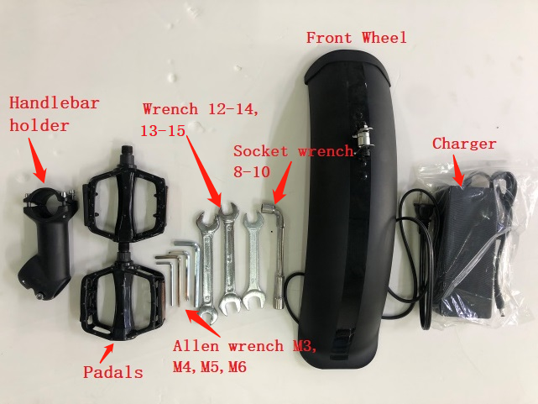
- •Step 2: Install the handlebar onto the fork. Make sure to center the handlebar and make sure the fork and handlebar bolts are locked.
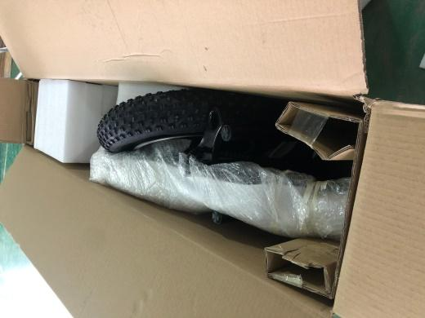
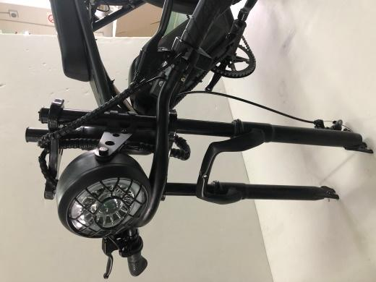

1.Check whether the outer carton is complete and unpack it
3. Take out the accessories and tooling kit
2. Take out the bicycle frame

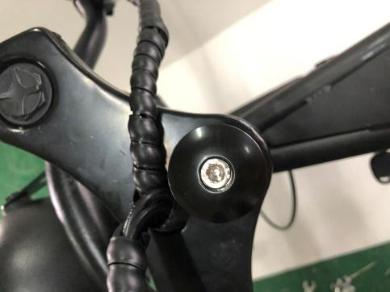
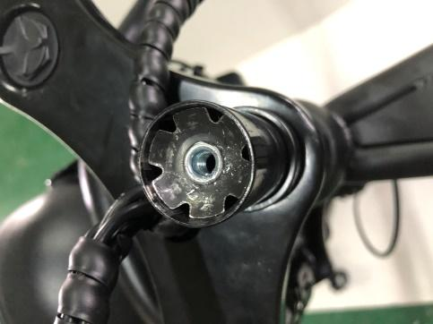

5. Use the M5 Allen wrench to unscrew the screw

4. Pull off the silicone protective cover on the top of front fork
6. Unscrew the screw and remove the trim cover
10

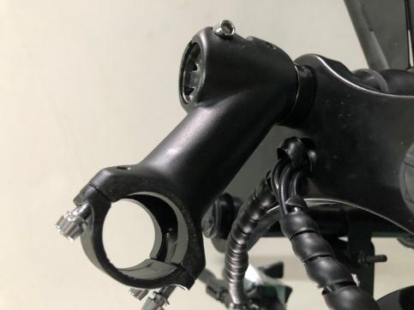
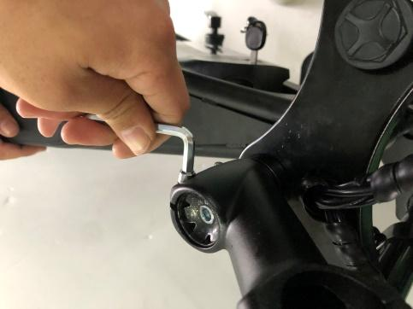
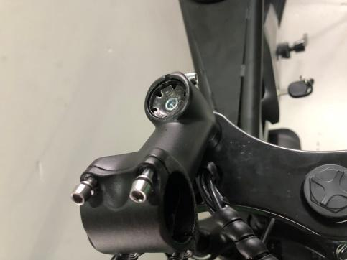

8. Adjust the direction of the handle holder so that it faces the front

9. Slightly unscrew the screw to fix it, the handlebar holder can be moved up and down, and not too tight
7. Take out the handle holder from the tooling kit and put it into the round tube of front fork

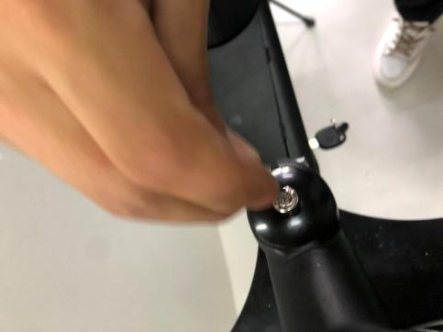
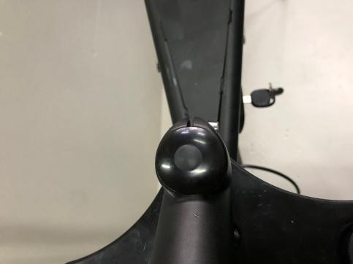
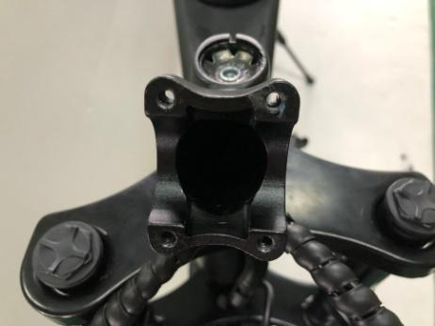

10. Put on the decorative cover and put in the screws

11. Tighten the screws with an M5 Allen wrench to make the front fork fit closely with the frame, and there should be no gaps and no shake.
12. Put on the silicone protective cover and tighten the side screws
11

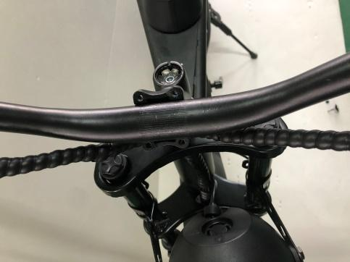
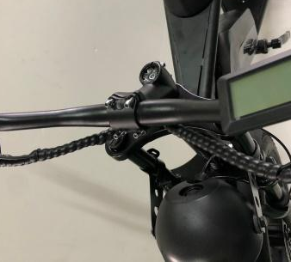
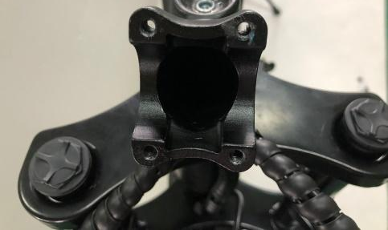

15.Place the cover parts back to the original position and screw the 4 screws
13. Use an M5 Allen wrench to unscrew the 4 screws on the handlebar holder, and remove the cover parts.

14.Put the handlebar and adjust the appropriate position

12
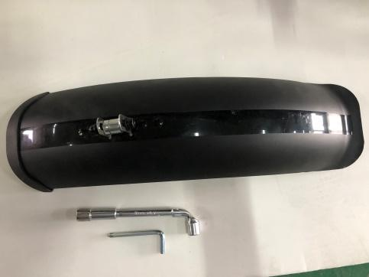
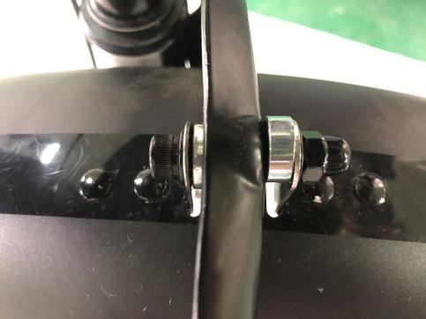

16. Take out the front fender and M5 Allen wrench and socket wrench from the tooling kit
17. Place small parts according to the sequence in picture
18. Tighten the screws until the front fender is not movable.
16
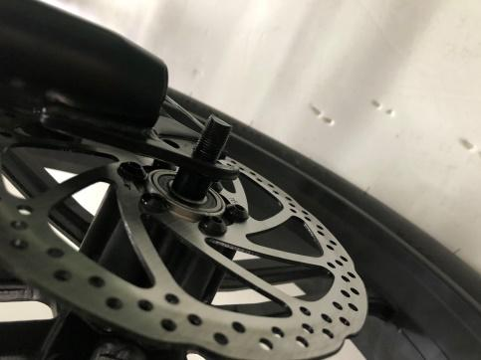
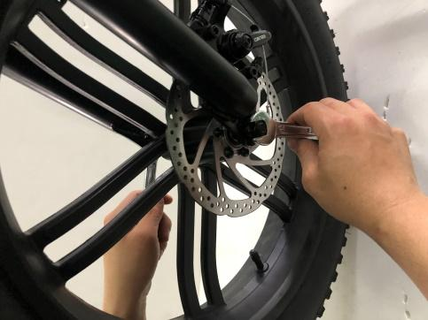
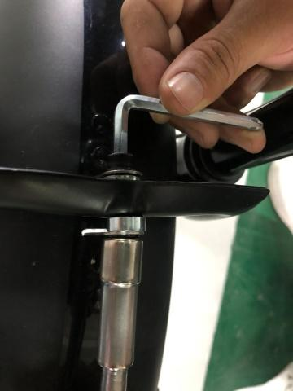
- Step 3: Install Front Fenders and Front Wheels

21. Tighten it with the 12-14 wrenchs until it is not loose.
13

19. Take out the disc brake from the tool box and install it on the front wheel, then insert the front wheel into the front fork slot
20.Place small parts according to the sequence in picture(same on both sides)

22. R for Right Pedal and
L for Left Pedal
25. Use the 13-15 wrench to tighten the pedal(same on both sides)
23.Insert the pedal(s) into this position
24. Slightly secure the pedals into the crank arms in a clockwise direction
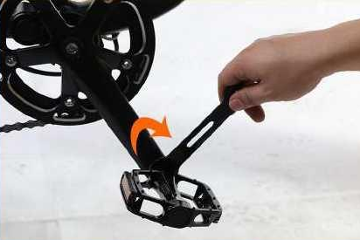
14

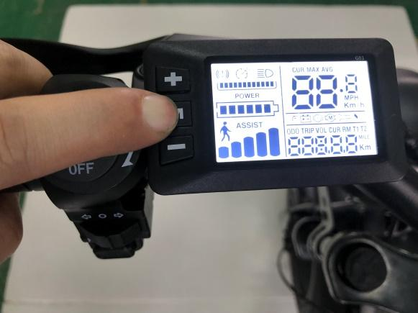
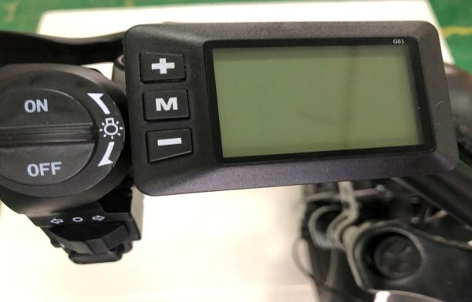
29. Use proper tire pressure
30. Put the rear fender bracket into the buckle, as shown in the picture, tighten the screws
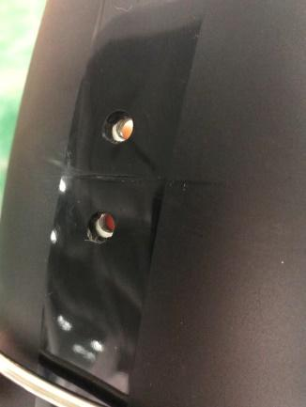
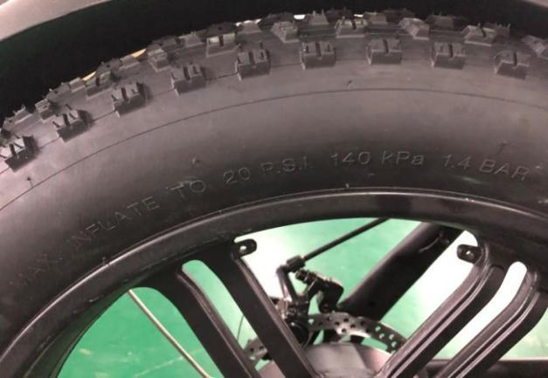
26. Display
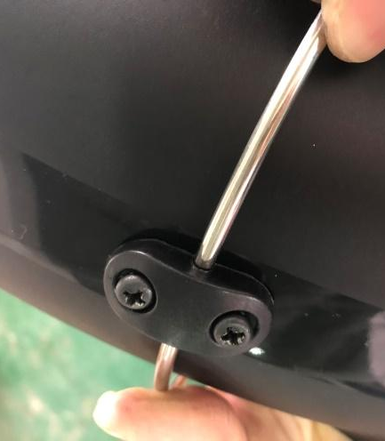
Step 4: Inflate tires to desired PSI. The recommended tire pressure is marked on the tire side. Do not over-inflate or under-inflate tires.
27. Press and hold the M button for 3 seconds to turn it on
28. Data showing on display

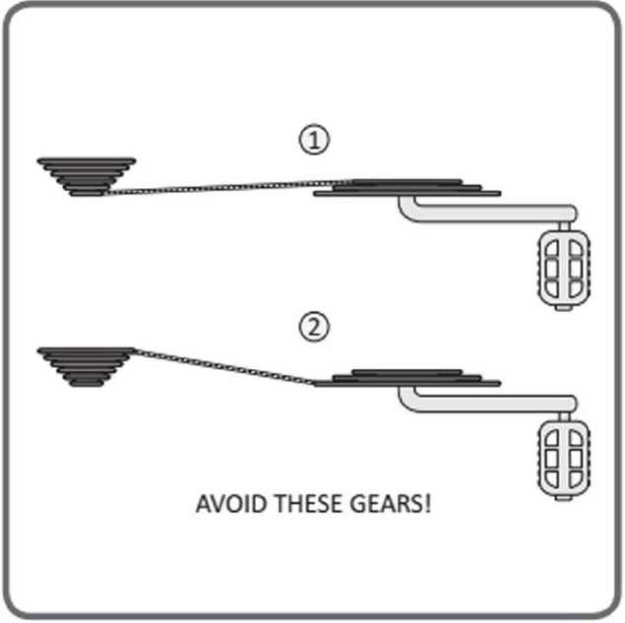
Gear Operation
Multi speed bicycles can have internal or derailleur gear systems. WARINNG Improper shifting can result in the chain jamming,or becoming derailed resulting in loss of control or a crash. Always be sure the chain is fully engaged in the desired gear before pedaling hard.
Avoid shifting while standing up on the pedals or under load.
To shift properly,pedal the bicycle with little pressure on the pedals, and move the shifter (1) gear at a time,ensuring that the chain is fully engaged in that gear before applying more pressure on the pedals. For bicycles with 3 front chain rings;avoid "Cross Chaining",which is the position when the chain is in the smallest cog in the rear combined with the inner or smallest chain ring in the front or the largest cog in the rear and the outer or largest chain ring in the front.These gear
positions put the chain at the most extreme angle and can cause premature wear to the drive train.Bicycles with 3 front chain rings have enough gear "overlaps" that these gears are not needed.
21
16
Charging Procedure
- Remove the rubber cover on the charging port on the opposite side of the battery from the key switch.
- With the battery on or off the bike, place the charger in a flat, secure place, and connect the DC output plug from the charger (round barrel connector) to the charging port on the side of the battery .
- Plug the charger into the outlet, then the charging port. Connect the charger input plug (100-240-volt plug) to the power outlet. Charging should initiate and will be indicated by the LED charge status light on the charger turning red.
4. Unplug the charger from the outlet, then the charging port. Once fully charged indicated by the charging indicator light turning green, unplug the charger from the wall outlet first and proceed to remove the charger

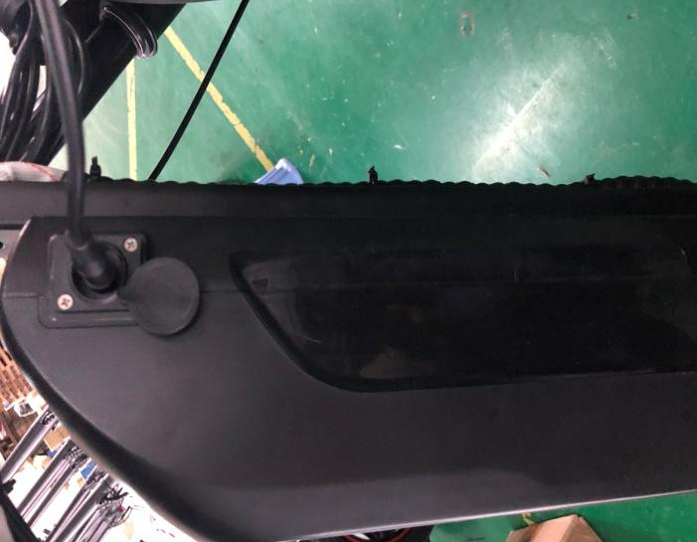
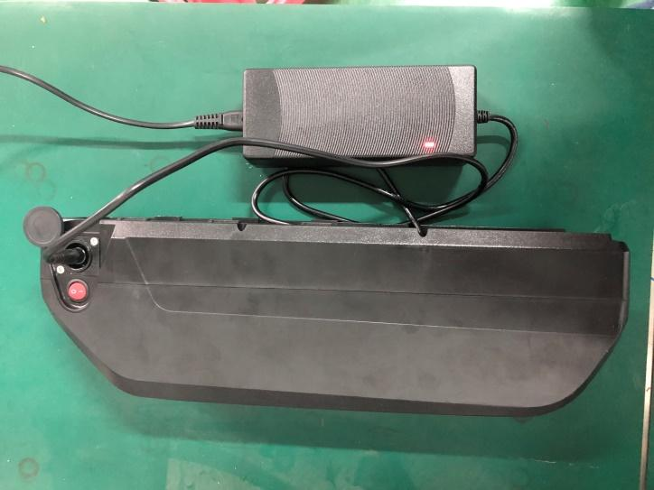

17
Attention:
Before charging make sure that charger light faces upwards; Full charge normally takes 3-7 hours; Charge battery in clean and safe place and do not over charge.

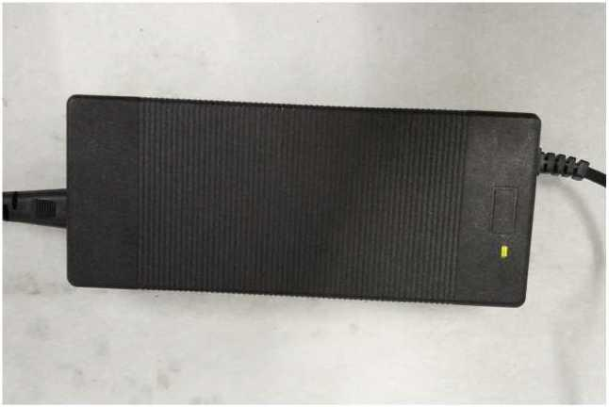
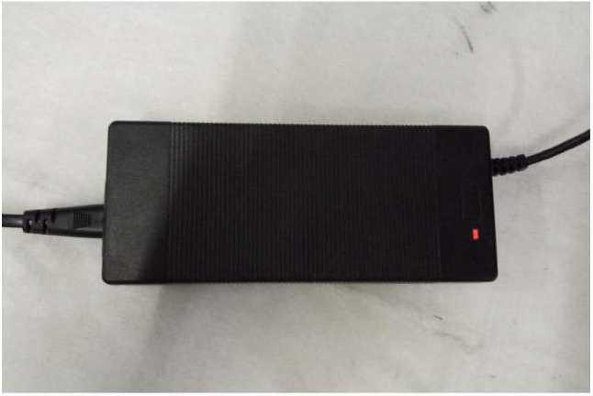

Red light means the battery is charging
Green light means the battery is full charged
18

Battery Charging Information
区Always charge your battery in temperatures between 50 °F - 77 °F (10 °C - 25 °C) and ensure the battery and charger are not damaged before initiating charge. If you notice anything unusual while charging, please discontinue charging and use of the bike and contact for help.
Charging the battery fully normally takes 3-7 hours. In rare cases, it may take longer to allow the battery management system to balance the battery, particularly when the bike is new or after long periods of storage.
The battery can be recharged on or off the bike.
Do not charge the battery for more than 12 hours at a time or leave a charging battery unattended.
Ensure the lights face upwards when using the charger. The charge indicator lights on the charger will stay red while the battery charges and one will turn green when charge is complete.
Always charge in dry, indoor locations away from direct sunlight, dirt, or debris. Charge in a clear area away from potential to trip on the charging cords or for damage to occur to the bike, battery, or charging equipment while parked and/or charging. Do not use with the charger inverted, which can inhibit cooling and reduce charger lifespan.
The battery should be recharged after each use, so it is ready to go the full range per charge next ride. There is no memory effect, so charging the battery after short rides will not cause damage.
Ensure the battery is turned off whenever it is being removed or off the bike. Avoid damaging the exposed connector terminals and keep them clear of debris.
Do not touch the "+" and terminal contacts on the bottom of the battery when the battery is removed from the bike.
19
Maintenance
Basic Bike Care:
To ensure safe riding conditions you must properly maintain your bike from e-bikes. Follow these basic guidelines and see a certified, reputable bike mechanic at regular intervals to ensure your bike is safe for use and fun to ride.
- Properly maintain batteries by keeping them fully charged when between uses of up to two weeks apart. See Long-Term Battery Storage section of manual for information on storing the battery for longer than two weeks between rides.
- Never immerse or submerge the bike or any components in water or liquid as the electrical system may be damaged.
- Periodically check wiring and connectors to ensure there is no damage and the connectors are secure.
- To clean, wipe the frame with a damp cloth. If needed, apply a mild non-corrosive detergent mixture to the damp cloth and wipe the frame. Dry by wiping with a clean, dry cloth.
- Store under shelter; avoid leaving the bike in the rain or exposed to corrosive materials. If exposed to rain, dry your bike afterwards and apply anti-rust treatment to chain and other unpainted steel surfaces.
- Riding on the beach or in coastal areas exposes your bike to salt, which is very corrosive. Wipe down your bike frequently and wipe or spray all unpainted parts with anti-rust treatment. Damage from corrosion is not covered under warranty so special care should be given to extend the life of your bike when used in coastal areas or areas with salty air or water.
- If the hub and bottom bracket bearings have been submerged in water or liquid, they should be taken out and re-greased. This will prevent accelerated bearing deterioration.
- If the paint has become scratched or chipped in the metal, use touch up paint to prevent rust. Clear nail polish can also be used as a preventative measure.
- Regularly clean and lubricate all moving parts, tighten components, and adjust as required.
20

Troubleshooting
Basic Troubleshooting:
 | Symptoms | Possible Causes | Most Common Solutions
1 | It doesn't work | 1.Insufficient battery power  - Faulty connections  - Battery not fully seated in tray  4.Improper turn on sequence  5.Brakes are applied | 1 .Charge the battery  2.Clean and repair connectors  3.Install battery correctly  - Turn on bike with proper sequence  - Disengage brakes
2 | Irregular acceleration and/ or reduced top speed | 1.Insufficient battery power  2.Loose or damaged throttle | - Charge or replace battery  - Replace throttle
3 | When powered on the motor does not respond | - Loose wiring  - Loose or damaged throttle  - Loose or damaged motor plug wire  - Damaged motor | 1 .Repair and or reconnect 2.Tighten or replace 3.Secure or replace 4.Repair or replace
4 | Reduced range | - Low tire pressure  - Low or faulty battery  - Driving with too many hills,headwind, braking,and/or excessive load  - Battery discharged for long period of time without regular charges(aged or damaged)  - Brakes rubbing | 1 .Adjust tire pressure  - Check connections or charge battery  - Assist with pedals or adjust route  - Replace the battery  - Adjust the brakes
21

5 | The battery won't charge | - Charger not well connected  - Charger damaged  - Battery damaged  - Wiring damaged | 1 .Adjust the connections  2.Repair or replace
6 | Wheel or motor makes strange noises | - Damaged motor bearings  - Damaged wheel spokes or rim  - Damaged motor wiring | 1 .Replace  - Repair or replace  - Repair or replace motor
7 | Sensor Issue | 1 .Sensor loose  2.Sensor or cable broken damaged | 1 .Adjust the connections  2.Repair or Replace
8 | Pre-load and turn off bike suddenly | - Battery or motor over heat protection  - Battery or controller cable loose  - Battery or controller cable damaged | - wait 1-3 minutes to restart e-bike  - Adjust the connections  - Repair or Replace
22
Safety Notes
The following safety notes provides additional information on the safe operation of your bike from E-bike and should be closely reviewed.Failure to review these notes can lead to serious injury or death.
□All user must read and understand this manual before their first use of the bike from E-bikes.Additional manuals for components used on the bike may also be provided and should be read before use in addition to this manual.
Ensure that you comprehend all instruction and safety notes/warnings.
Ensure the bike fits you properly before your first use.You may lose control or fall if your bike is too big or too small. Always wear an approved bicycle helmet whenever using this product and ensure that all helmet manufacturer instructions are used for fit and care of your helmet.Failure to wear a helmet when riding may result in serious injury or death.
Ensure correct setup and tightening is performed on your bike before first using it and check the setup,tightening,and condition regularly.
lt is your responsibility to familiarize yourself with the laws and requirements of operating this product in the area(s) where you ride.
Ensure the handlebar grips are undamaged and properly installed.Loose or damaged grips can cause you to lose control and fall.
D0 not use this product with standard bike trailers,stands,vehicle racks or accessories that E-bikes has not tested for safety and compatibility and have verified as safe and compatible with the bike.Contact E-bikes to check if your equipment will work with the bike.
Off-road riding requires close attention,specific skills,and presents variable conditions and hazards which accompany the conditions.Wear appropriate safety gear and do not ride alone in remote areas.Check local rules and regulations if off-road E-bike riding is allowed.
Engaging in extreme riding is extremely dangerous and should be avoided.Although many articles/advertisements/ catalogs depict extreme riding,this is not recommended nor permitted,and you can be seriously injured or killed if you perform extreme riding.
Bikes and bike parts have strength and integrity limitations and extreme riding should not be performed as it can damage bike components and/or cause or lead to dangerous riding situations in which you may be seriously injured or killed.。
Failure perform and confirm proper installation,compatibility,proper operation,or maintenance of any component or accessory can result in serious injury or death.
lt is recommended to not ride at night if avoidable.Ride at night only if necessary.
23
36

